*Multiple Authentication In Laravel 12 Using Breeze*

* **Step 1:** Create New Laravel Project
* Laravel new project
* **Step 2:** Install Laravel Breeze
* composer require laravel/breeze –dev
* php artisan breeze:install
* npm install
* npm run build
* **Step 3:** Create Migration and Update Model
* php artisan make:migration add_type_to_users_table

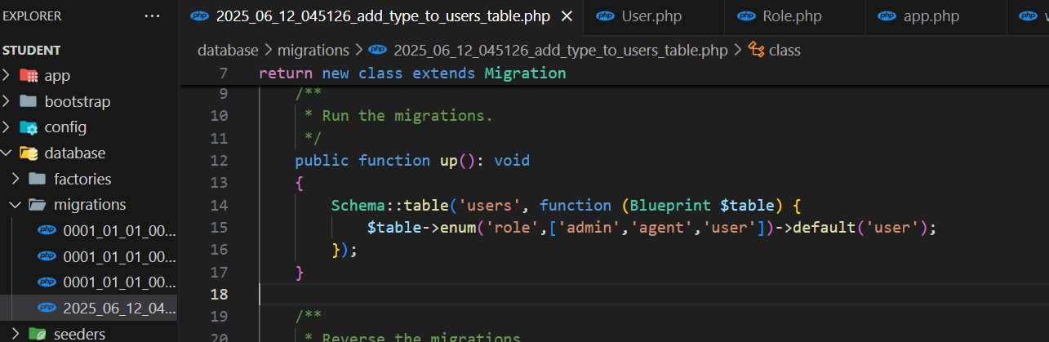

***Now Run Migration :***

php artisan migrate

***Update User Model :***

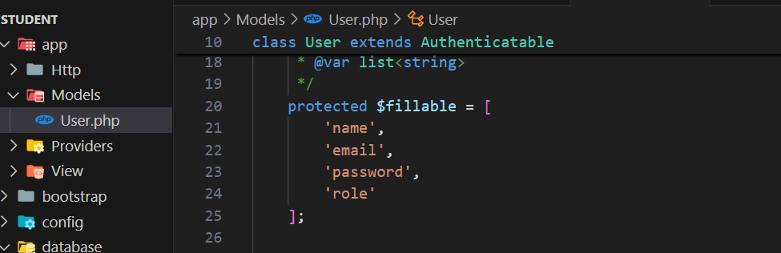

* **Step 4:** Create UserAccess Middleware
* php artisan make:middleware Role

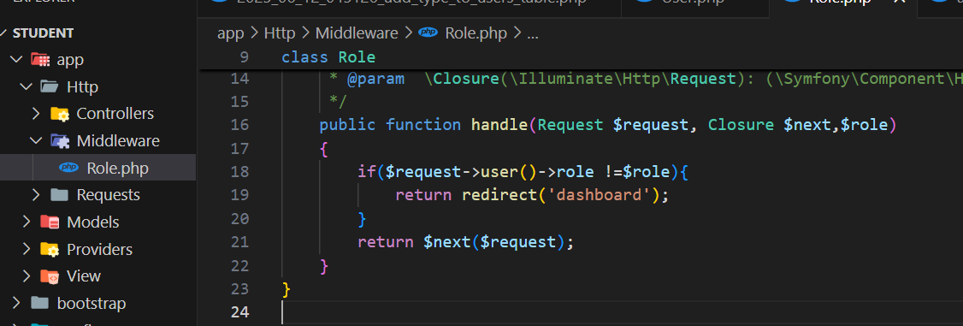

Now register middleware

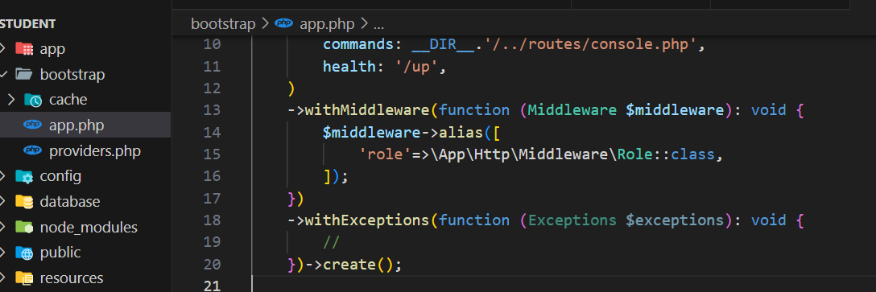

* **Step 5:** Create Routes

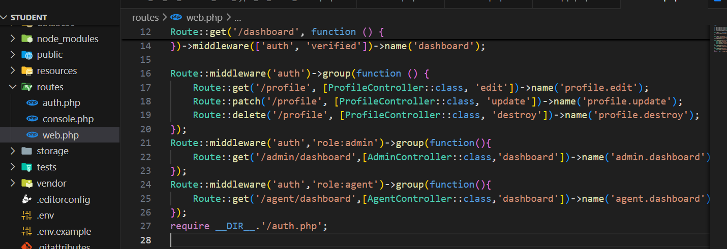

* **Step 6:** Update Controller
* php artisan make:controller AdminController
* php artisan make:controller AgentController

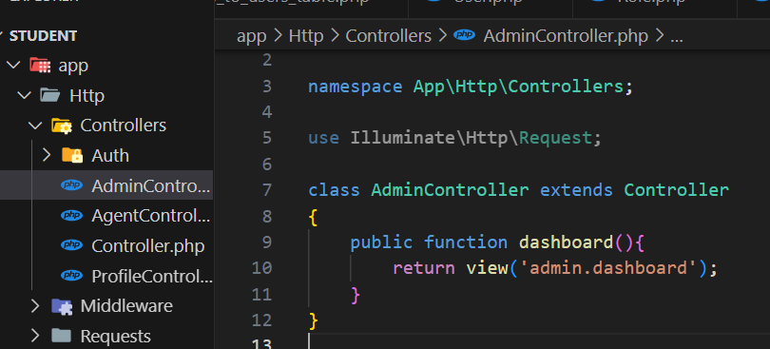

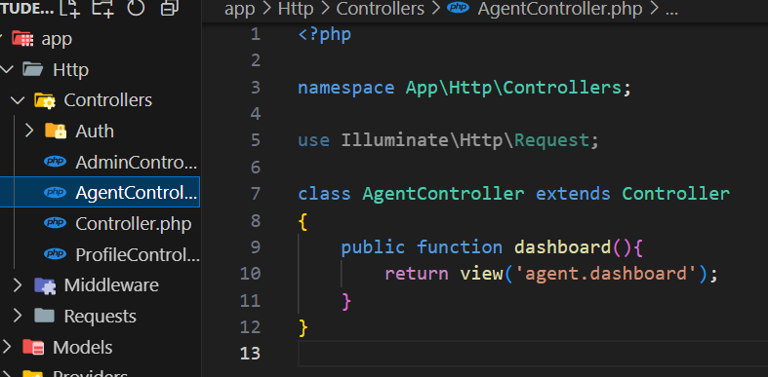

* **Step 7:** Create Blade Files

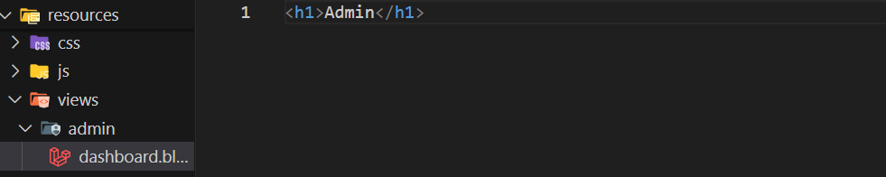

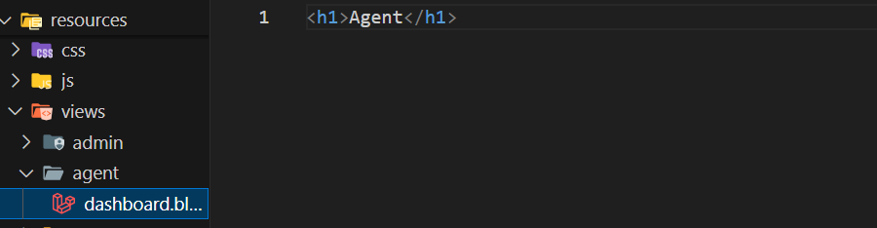

* **Step 8:** Update LoginController File

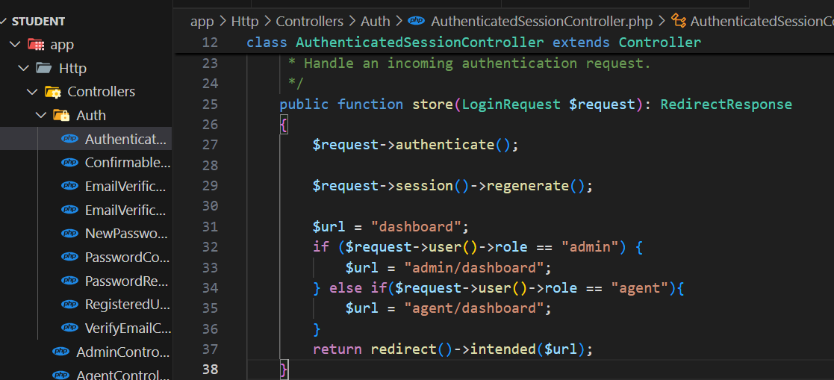

* **Step 9:** Create User Seeder
* php artisan make:seeder UserSeeder

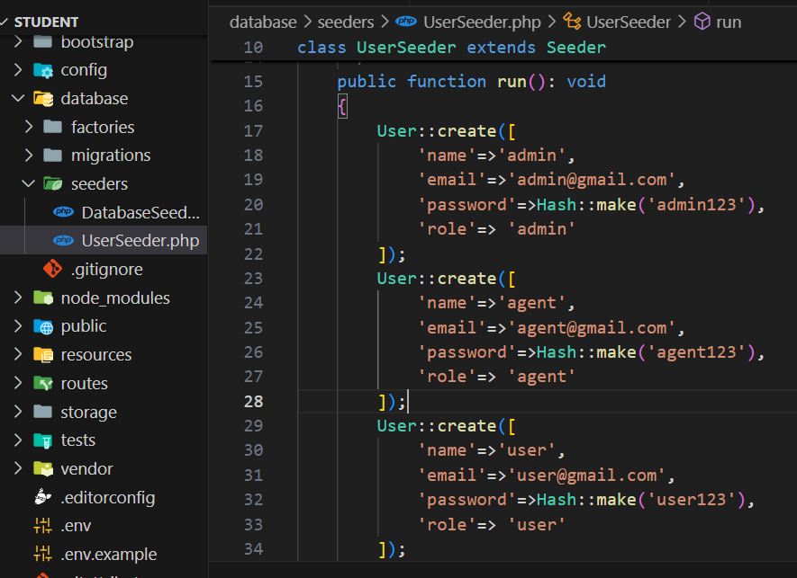

php artisan db:seed --class=UserSeeder

* **Run Laravel App**
* php artisan serve